**Project 1: Observing the Moon**

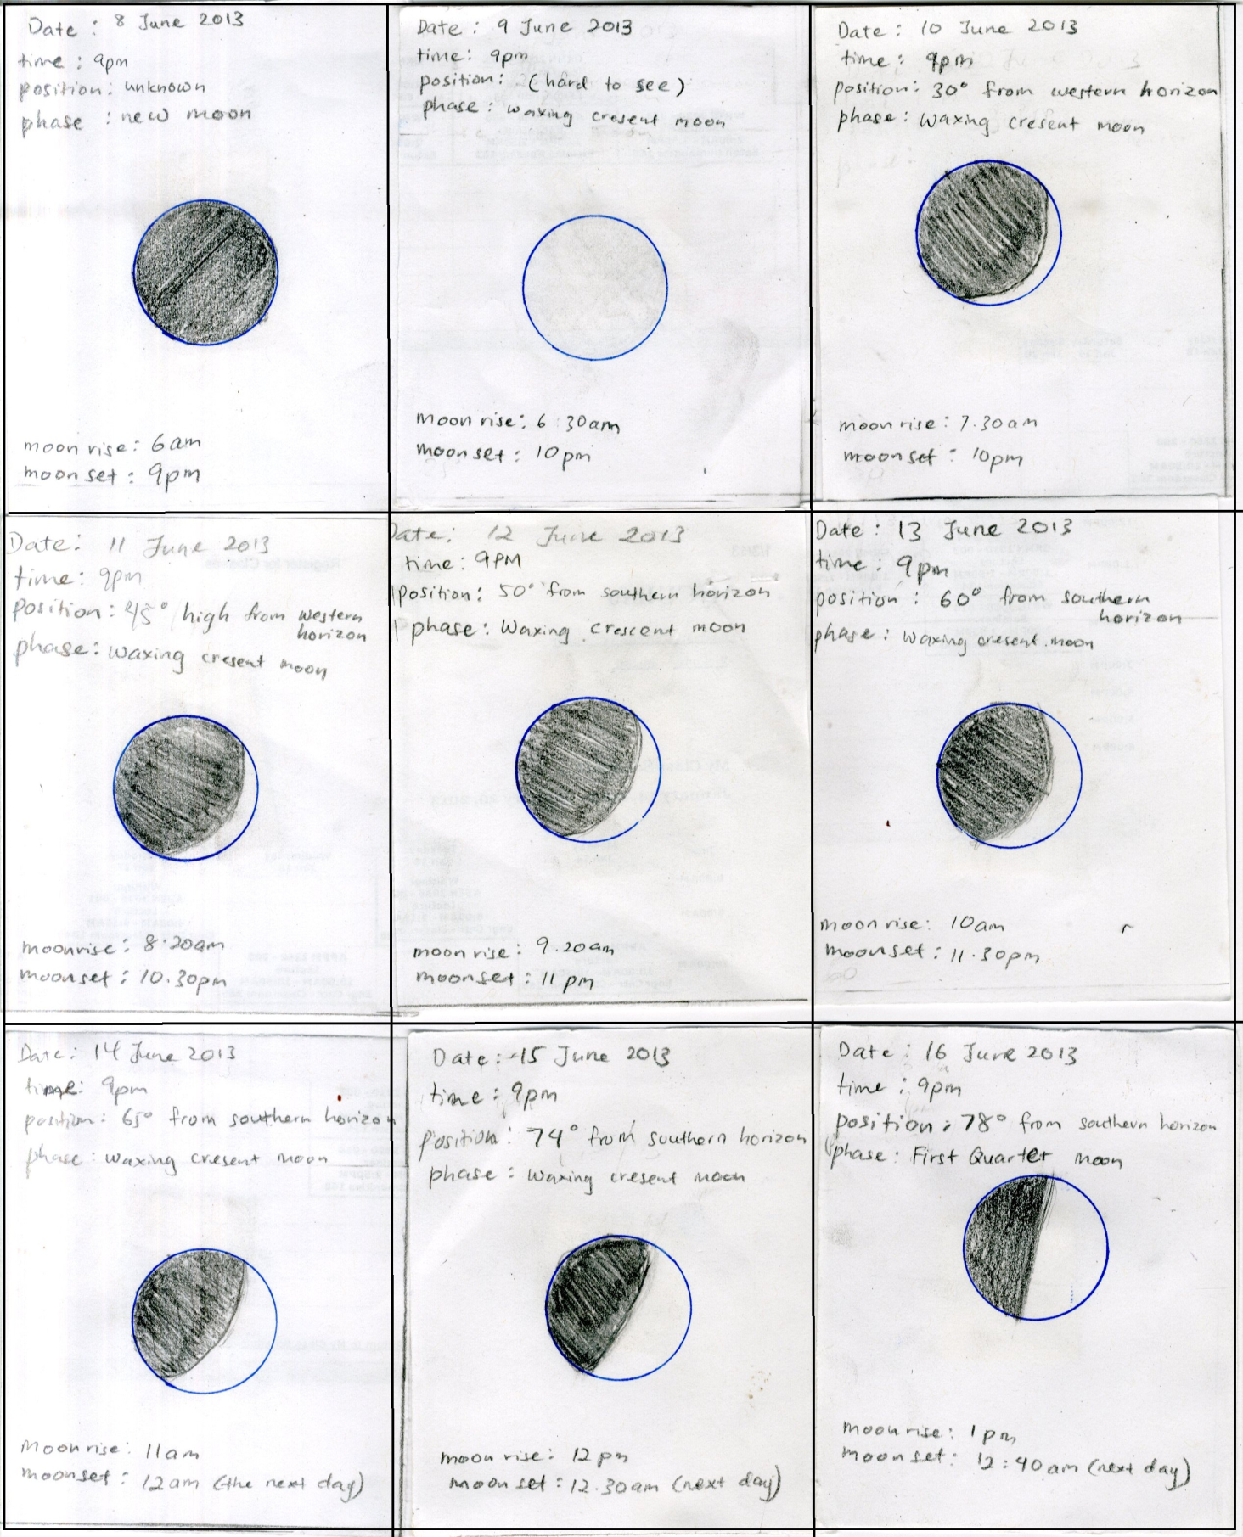

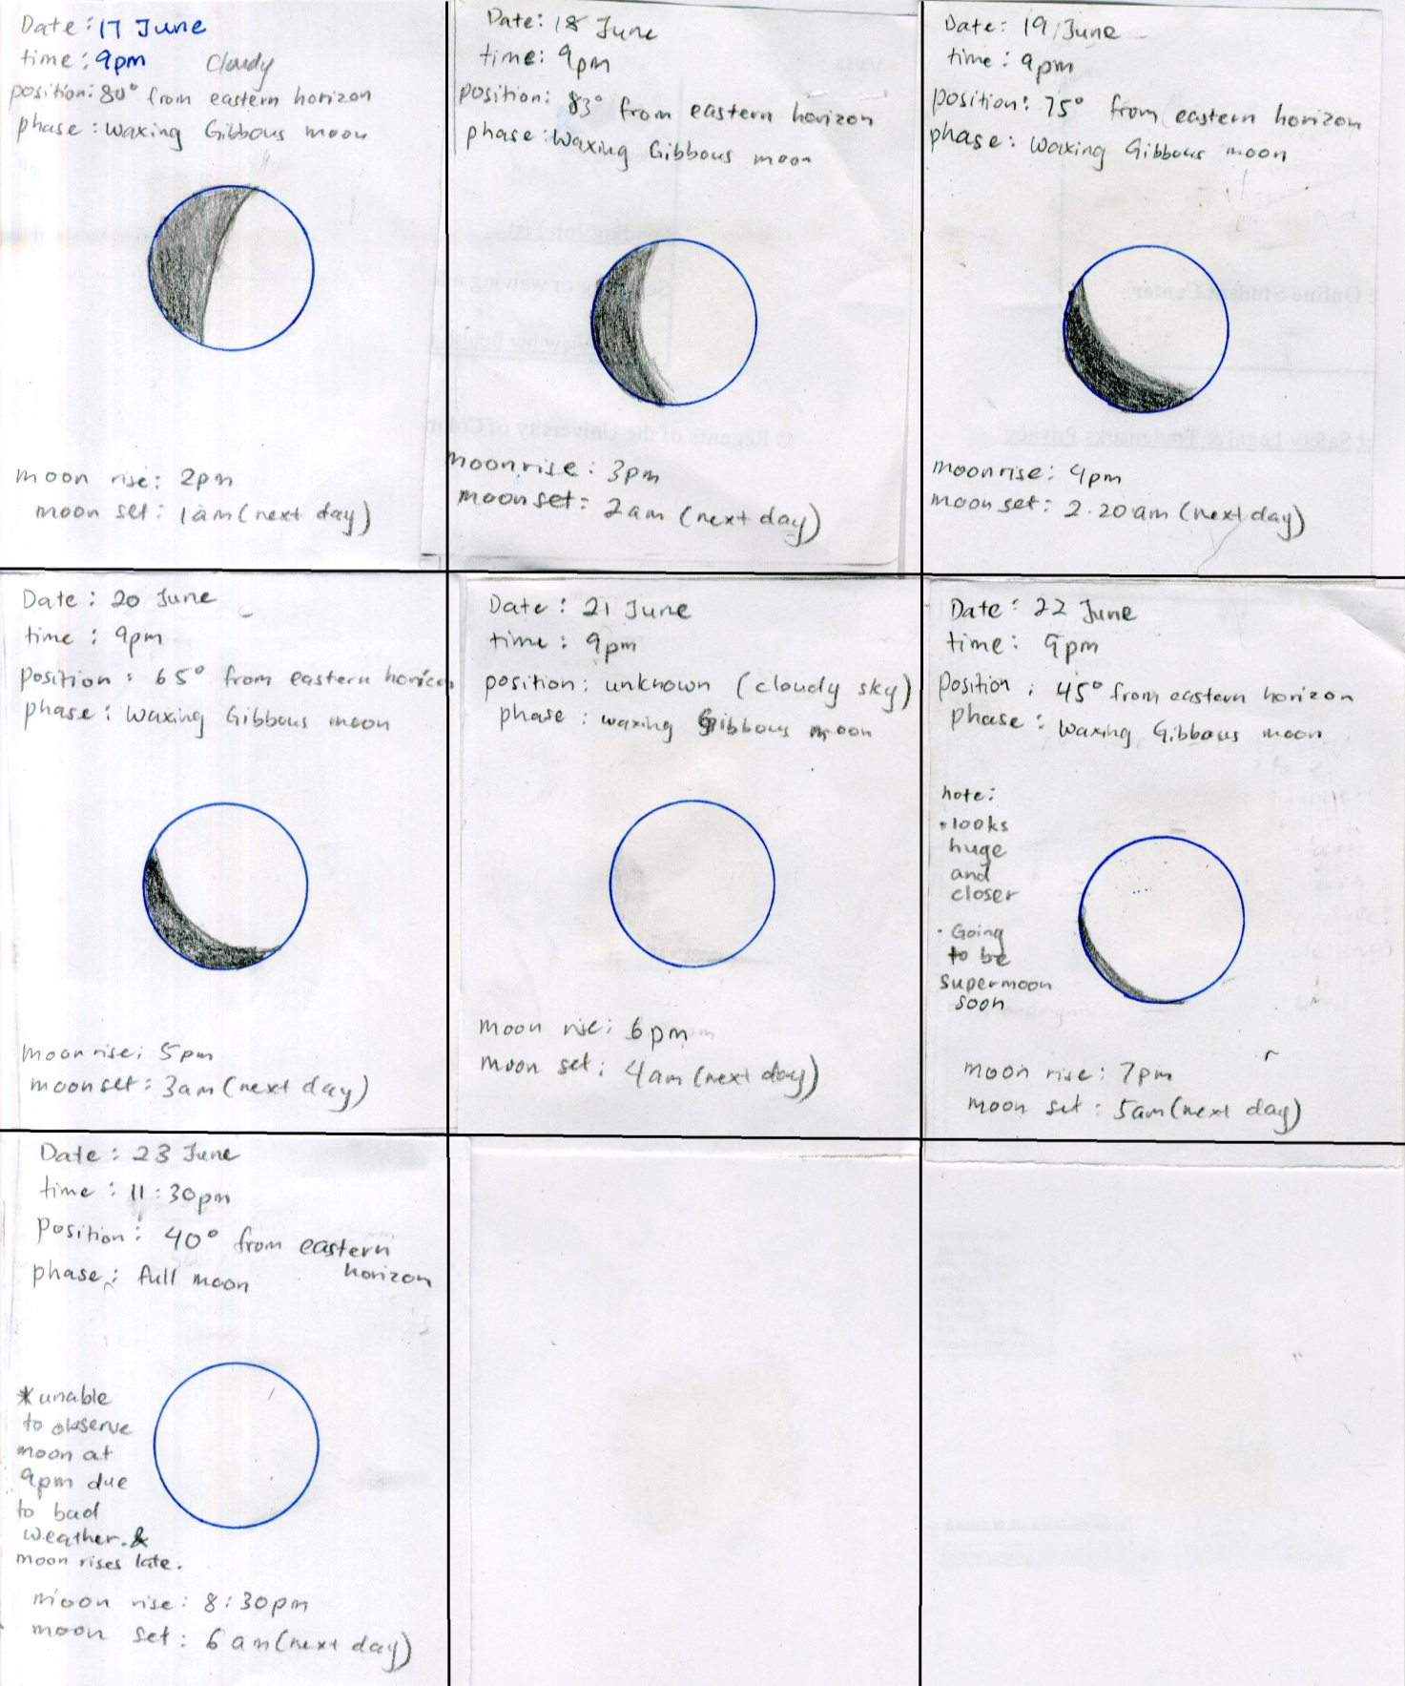

Note: The shaded region represents the shadow while the non-shaded region shows the part of the moon that is lit up.

1. **(10 pts) Why does the amount of the moon that is lit up change from night to night?**

The amount of moon that is lit up changes every night because the position of the moon changes as it orbits around the Earth. It shows the amount of surface area of the moon that is facing the sun and due to the angle at which we observe the moon changes as it rotates around the earth.

1. **(10 pts) Why must your observations be made at the same time every day for this project to work?**

Observation must be made at the same time every day so that we can observe the changes of moon’s position and its altitude from the horizon.

1. **(10 pts) Why couldn't we continue this project in the same way for a full month?**

The moon rises and sets at different time each day due to the changes of moon’s position as it orbits around Earth and the Earth’s spin. The time for the moon to rise becomes longer as it slowly shifts from morning to afternoon. Just like in the diagram (1) and (2), the time for the moon to rise and set changes as the phase of the moon also changes. So if we continue the same steps for a full moon, we are unable to record the moon after the full moon since the moon will rise later.

1. **(20 pts) Explain the main reason why the position of the moon in the sky changes over the course of a single night. In other words why is the moon in a different position in the sky at 11:00 than it was as 9:00?**

It takes the Moon 27.322 days to go around the Earth once. Because of this motion, the Moon appears to move about 13° each day. If you observe the Moon over the course of several hours one night, you will notice that its position among the stars will change by a few degrees.

1. **(20 pts) Explain why the position of the moon in the sky changes from night to night, so that at 9:00 tomorrow it will be at a different position in the sky than it was at 9:00 today.**

The moon rises in the east and sets in the west. The Earth orbits counterclockwise around the sun while the moon also orbits counterclockwise around earth.  If you watch the moon some night and notice its position compared to some nearby stars, you will see that in one hour its position relative to the stars will have changed by about one moon-diameter. This is because of the slow eastward motion; the moon rises every day about 50 minutes later than the day before.

1. **(+20 pts or -100 pts) When the moon is in the first quarter phase, half of it is lit up and half is in shadow. In other words, what object blocks the light, leaving half of the moon in shadow? Carefully explain your answer. (Warning: If you give an answer that is VERY wrong, I will take off 100 points.)**

When the moon is in the first quarter phase, half of it is lit up and half is in shadow because of its position at a 90 degree angle with respect to the earth and the sun. The bright part of the moon is lit by the sun while the dark part is the moon’s shadow.